AI BLOGNEST API

AI-POWERED BACKEND REST API FOR INTELLIGENT BLOG CONTENT GENERATION AND SEARCH

PROJECT DOCUMENTATION
Submitted By:
Team ID:SWTID-2026-2693
Team Leader: Monisha N
Team Member: Merlin Angelina L
Team Member: Pooja K
Team Member: Gifta S
Course: B.Sc. Computer Science with Artificial Intelligence
College: DRBCCC Hindu College
University: University of Madras
Academic Year: 2026-2027

1. ABSTRACT
AI BlogNest API is a backend application designed to support AI-assisted blogging and content management through a REST-based architecture. The project is developed using Node.js and Express.js, with MongoDB used as the database through the Mongoose ODM.
The application integrates Google Gemini AI to provide intelligent content-related capabilities. The Gemini integration is configured through environment variables, allowing the application to communicate with the selected Gemini model without exposing API credentials directly in the source code.
The backend uses JSON Web Tokens (JWT) for authentication and bcryptjs for secure password hashing. Authentication-related configuration includes a configurable JWT secret and a seven-day token expiration period. This provides a mechanism for maintaining authenticated sessions while protecting user credentials.
AI BlogNest API also incorporates several backend security and reliability mechanisms. Express Validator is used for request validation, Helmet provides HTTP security headers, Express Rate Limit helps restrict excessive requests, and CORS is configured to control communication between the backend and the frontend development environment. Morgan is included for HTTP request logging.
The application follows a modular Node.js backend approach in which dependencies and development tools are managed through npm. Environment-specific settings are separated from application code using dotenv. The project supports both local MongoDB development and MongoDB Atlas deployment configurations.
The overall objective of AI BlogNest API is to provide a secure and maintainable backend foundation for an AI-powered blogging platform.

2. INTRODUCTION

Blogging applications provide users with a platform for creating, managing, and sharing written content. Modern blogging systems increasingly require more than basic content storage because users expect intelligent assistance, secure authentication, efficient content management, and reliable backend services.

Creating and managing blog content manually can require considerable time and effort. AI-based services can assist users by providing intelligent content-generation capabilities and reducing repetitive content-related work.

AI BlogNest API addresses this requirement by providing a backend REST API with an integrated Generative AI service. The backend is developed using Node.js and Express.js, while MongoDB provides persistent data storage through Mongoose.

Security is another important requirement of the system. The project uses JWT authentication, bcryptjs password hashing, Helmet security middleware, request validation, rate limiting, and CORS configuration. These technologies provide a foundation for protecting authenticated resources and handling API requests safely.

The project also separates configuration values such as database connection strings, JWT settings, Gemini API credentials, server ports, and CORS origins into environment variables. This approach improves configuration management and prevents sensitive configuration values from being hard-coded into the application.

AI BlogNest API is therefore designed as a backend foundation for an intelligent blogging system that combines REST API development, database management, authentication, security, and Generative AI.

3. PROJECT TITLE

AI BlogNest API

Project Theme

AI-Powered Backend REST API for Intelligent Blog Content Management

4. PROJECT DESCRIPTION
AI BlogNest API is a backend REST API project developed to provide the foundation for an AI-assisted blogging and content management application.
The backend is implemented using Node.js and Express.js. MongoDB is used as the database, with Mongoose providing an object-document mapping layer between the Node.js application and MongoDB.
The project integrates Google Gemini through the @google/genai package. The Gemini API key and selected Gemini model are configured using environment variables, allowing AI capabilities to be managed independently from the application source code.
Authentication is supported through JSON Web Tokens. Passwords can be protected using bcryptjs hashing before being stored in the database. JWT configuration includes a configurable secret and a seven-day expiration period.
The backend also includes several middleware components for improving security and reliability:
- CORS for controlling cross-origin requests
- Helmet for HTTP security headers
- Express Rate Limit for limiting excessive requests
- Express Validator for validating incoming request data
- Morgan for HTTP request logging
- dotenv for environment configuration
The project supports separate configuration environments for local development and deployment. Local development can use a MongoDB database running on the local machine, while the deployment configuration can connect to MongoDB Atlas.
The project is intended to serve as the backend layer for an AI-enabled blogging platform and can be extended with additional blog, user, content, and AI-related modules.

5. PROBLEM STATEMENT
Traditional blogging applications can involve several challenges related to content creation, backend management, security, and configuration.

5.1 Manual Content Creation

Creating blog content manually can require significant time and effort. AI-assisted content generation can help reduce the effort required to produce initial content.

5.2 Lack of AI Assistance

Basic blogging backends generally focus on storing and retrieving content. They may not provide an integrated Generative AI service for intelligent content-related operations.

5.3 Authentication and Security

Backend applications need mechanisms to authenticate users and protect sensitive operations. Passwords should not be stored as plain text, and authenticated requests should be protected using secure authentication mechanisms.

5.4 Request Validation

Invalid or unexpected input can cause application errors or create security risks. A backend therefore requires validation of incoming request data.

5.5 Excessive API Requests

Publicly accessible APIs can receive excessive requests. Rate limiting is useful for reducing abuse and controlling the number of requests handled by the application.

5.6 Configuration Management

Database credentials, authentication secrets, API keys, server ports, and frontend origins should not be hard-coded into application source files. Environment variables provide a safer and more flexible configuration mechanism.

5.7 Development and Deployment Differences

A project may use a local MongoDB database during development while using MongoDB Atlas during deployment. The backend therefore requires configuration that can be changed according to the execution environment.

6. PROPOSED SOLUTION
AI BlogNest API provides a centralized backend solution for an AI-assisted blogging application.

The proposed backend provides the following technical capabilities:

- Node.js-based backend execution
- Express.js REST API framework
- MongoDB database integration
- Mongoose database management
- JWT-based authentication
- bcryptjs password hashing
- Google Gemini AI integration
- Request validation using Express Validator
- HTTP security headers using Helmet
- API rate limiting
- CORS configuration
- HTTP request logging using Morgan
- Environment-based configuration using dotenv
- Slug generation using Slugify
- Local MongoDB development support
- MongoDB Atlas deployment support
- Configurable Gemini model selection

The architecture provides a foundation that can be extended with specific blogging modules and REST endpoints according to the requirements of the application.

7. OBJECTIVES
7.1 Primary Objectives
- To develop a backend REST API for an AI-assisted blogging platform.
- To implement the backend using Node.js and Express.js.
- To integrate MongoDB as the application's database.
- To use Mongoose for database interaction and data modeling.
- To implement JWT-based authentication.
- To protect passwords using bcryptjs hashing.
- To integrate Google Gemini Generative AI.
- To provide a configurable AI model through environment variables.
- To validate incoming API requests.
- To improve backend security using standard security middleware.
- To implement API rate limiting.
- To provide request logging for backend monitoring.
- To support local and cloud database configurations.
- To maintain configuration separately from application source code.
7.2 Secondary Objectives
- To create a maintainable backend architecture.
- To improve the security of API requests.
- To simplify local development and deployment.
- To reduce manual configuration changes between environments.
- To provide a foundation for future blog management features.
- To integrate Artificial Intelligence into a conventional backend application.
8. SCOPE OF THE PROJECT
The scope of AI BlogNest API focuses on the backend services required for an AI-assisted blogging platform.
The project includes backend technologies for:
- API development
- Database connectivity
- Authentication
- Password protection
- AI integration
- Request validation
- Security middleware
- Rate limiting
- Logging
- Cross-origin communication
- Environment configuration
The project is backend-focused. A separate frontend client can communicate with the backend through the configured API server.
The project can also be extended in the future with additional blogging functionality, administrative features, content workflows, analytics, search, and other intelligent services.

9. SYSTEM REQUIREMENTS

9.1 Software Requirements

Component | Requirement
Operating System | Windows / macOS / Linux
Runtime | Node.js
Package Manager | npm
Backend Framework | Express.js
Database | MongoDB / MongoDB Atlas
ODM | Mongoose
Authentication | JSON Web Token
Password Security | bcryptjs
AI Service | Google Gemini
Request Validation | Express Validator
Security Headers | Helmet
Rate Limiting | Express Rate Limit
Logging | Morgan
Configuration | dotenv
CORS | cors
Slug Generation | slugify
Development Tool | Nodemon
API Testing | REST API testing tools such as Postman
The project requires a Node.js environment capable of running the installed dependencies. The project configuration also supports a MongoDB database and a Gemini API key for AI-related functionality.
9.2 Hardware Requirements
- Minimum 4 GB RAM
- Recommended 8 GB RAM or above
- Modern dual-core processor or above
- Sufficient storage for Node.js dependencies and project files
- Internet connection for MongoDB Atlas and Google Gemini services when using cloud-based functionality

10. TECHNOLOGY USED

10.1 Node.js

Node.js provides the runtime environment for executing the backend JavaScript application. It allows the project to run server-side JavaScript and manage API requests.

10.2 Express.js
Express.js is used as the backend web framework. It provides the foundation for building REST APIs and managing
middleware and HTTP requests.

10.3 MongoDB

MongoDB is used as the application's NoSQL database. The project supports a local MongoDB database during development and MongoDB Atlas for cloud deployment.

10.4 Mongoose

Mongoose provides the database abstraction layer for MongoDB. It allows the application to work with MongoDB using structured models and database operations.

10.5 JSON Web Token

JSON Web Token is used to implement authentication. The project uses a configurable JWT secret and sets the token expiration period to seven days.

10.6 bcryptjs

bcryptjs is used for password hashing. Password hashing helps prevent passwords from being stored directly in plain-text form.

10.7 Google Gemini

Google Gemini provides the Generative AI capability of the project. The application uses the @google/genai package to communicate with the Gemini service.
The Gemini model is configurable through the GEMINI_MODEL environment variable.

10.8 Express Validator

Express Validator is used for validating incoming request data. Validation helps ensure that API inputs meet the expected requirements.

10.9 Helmet

Helmet is used to improve backend security by adding appropriate HTTP security headers to responses.

10.10 Express Rate Limit

Express Rate Limit is used to control excessive API requests and provide an additional layer of protection against request abuse.

11. SYSTEM ARCHITECTURE

AI BlogNest API follows a backend REST API architecture.
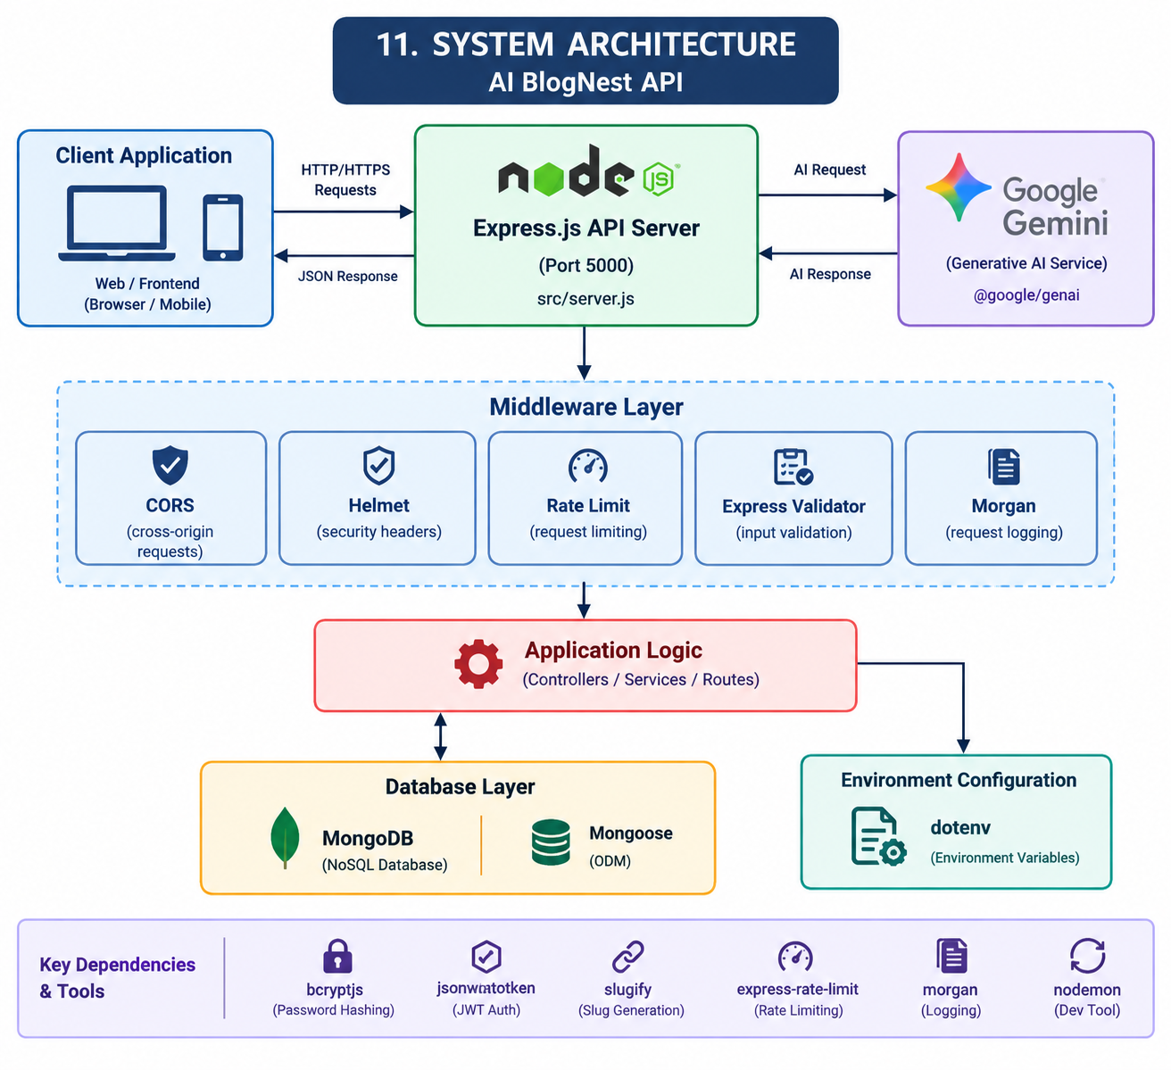
The main processing flow can be represented as:
Client Application
↓
Express.js API Server
↓
Middleware Layer
↓
Application Logic
↓
MongoDB / Mongoose

For AI-related operations:
Client Request
↓
Express.js API
↓
AI Application Logic
↓
Google Gemini API
↓
AI Response
↓
Client
The middleware layer can include authentication, validation, security headers, CORS handling, rate limiting, and request logging.
The database layer uses Mongoose to communicate with MongoDB.

12. BACKEND ARCHITECTURE

AI BlogNest API is organized as a Node.js backend application.
The project configuration identifies src/server.js as the main application entry point.
The backend architecture can be divided conceptually into the following layers:

12.1 Server Layer

The server layer starts the Express.js application and listens on the configured port.
The project uses port 5000 by default through the environment configuration.

12.2 Middleware Layer

Middleware is responsible for common request-processing and security tasks.

The project includes:
- CORS
- Helmet
- Express Rate Limit
- Express Validator
- Morgan

12.3 Authentication Layer

JWT and bcryptjs are included to support secure authentication.
JWT provides authenticated request tokens while bcryptjs provides password hashing.

12.4 Database Layer

MongoDB is used for persistent storage and Mongoose provides the database interaction layer.

12.5 AI Integration Layer

The @google/genai package provides communication with Google Gemini.
The Gemini API key and model are supplied through environment variables.

12.6 Configuration Layer

dotenv loads environment-specific configuration values before the application starts.
This keeps configuration separate from the main application logic.

13. DATABASE DESIGN
- The project uses MongoDB as its database technology.
- Two database environments are configured:

Local Development Database

- The local configuration uses:
- Database: ai_blog_nest
- This allows developers to run the project with a MongoDB instance on the local machine.

Deployment Database

- The deployment configuration uses MongoDB Atlas.
- MongoDB Atlas provides a cloud-hosted MongoDB environment that can be used when deploying the backend.
- Mongoose is used as the ODM layer between the Express application and MongoDB.
- The exact collection names, document fields, and relationships are defined by the application's model implementation. These details are not established by the configuration files alone.

14.USER ENTITY
The project includes JWT and bcryptjs dependencies for authentication-related functionality.
The authentication system requires user-related information such as credentials and authentication data.
Passwords should be stored in hashed form using bcryptjs rather than plain text.
The exact User schema and fields are determined by the application's model implementation and are not specified in the configuration files provided for this documentation.

15.BLOG ENTITY

AI BlogNest is intended to support blogging and content management.

The package description identifies the application as a secure AI blogging and content management platform.
The exact Blog schema, fields, relationships, status values, and database operations depend on the implementation of the project's source files.
The provided configuration confirms the technologies required to support blog data storage:
- MongoDB
- Mongoose
- Express.js
- Slugify
- Google Gemini

16. CONTENT MANAGEMENT

AI BlogNest API is designed around the concept of AI-assisted blogging and content management.
The backend provides the technical foundation required for managing application data through REST APIs.
Mongoose can be used to define and manage blog-related data structures, while MongoDB provides persistent storage.
Slugify is included to support the creation of URL-friendly identifiers for content.
The specific content-management operations and endpoint structure are defined by the application's controller and route implementation.

17. AUTHENTICATION
Authentication is an important part of the AI BlogNest API.
The project includes JSON Web Token and bcryptjs dependencies.
JWT provides token-based authentication for protected API requests.

The project configuration contains:
- JWT secret configuration
- JWT expiration configuration
- Seven-day JWT expiration

The authentication process can be represented as:

User Credentials
↓
Credential Verification
↓
Password Hash Verification
↓
JWT Generation
↓
Authenticated API Request

The actual authentication endpoints are determined by the project's route implementation.

18. PASSWORD SECURITY

- Password protection is implemented using bcryptjs.
- Instead of storing user passwords directly, the backend can hash passwords before storing them in the database.
- During authentication, the provided password can be compared against the stored password hash.
- This provides an additional layer of protection for user credentials.

19. ENTITY RELATIONSHIP DIAGRAM
The main relationships are:
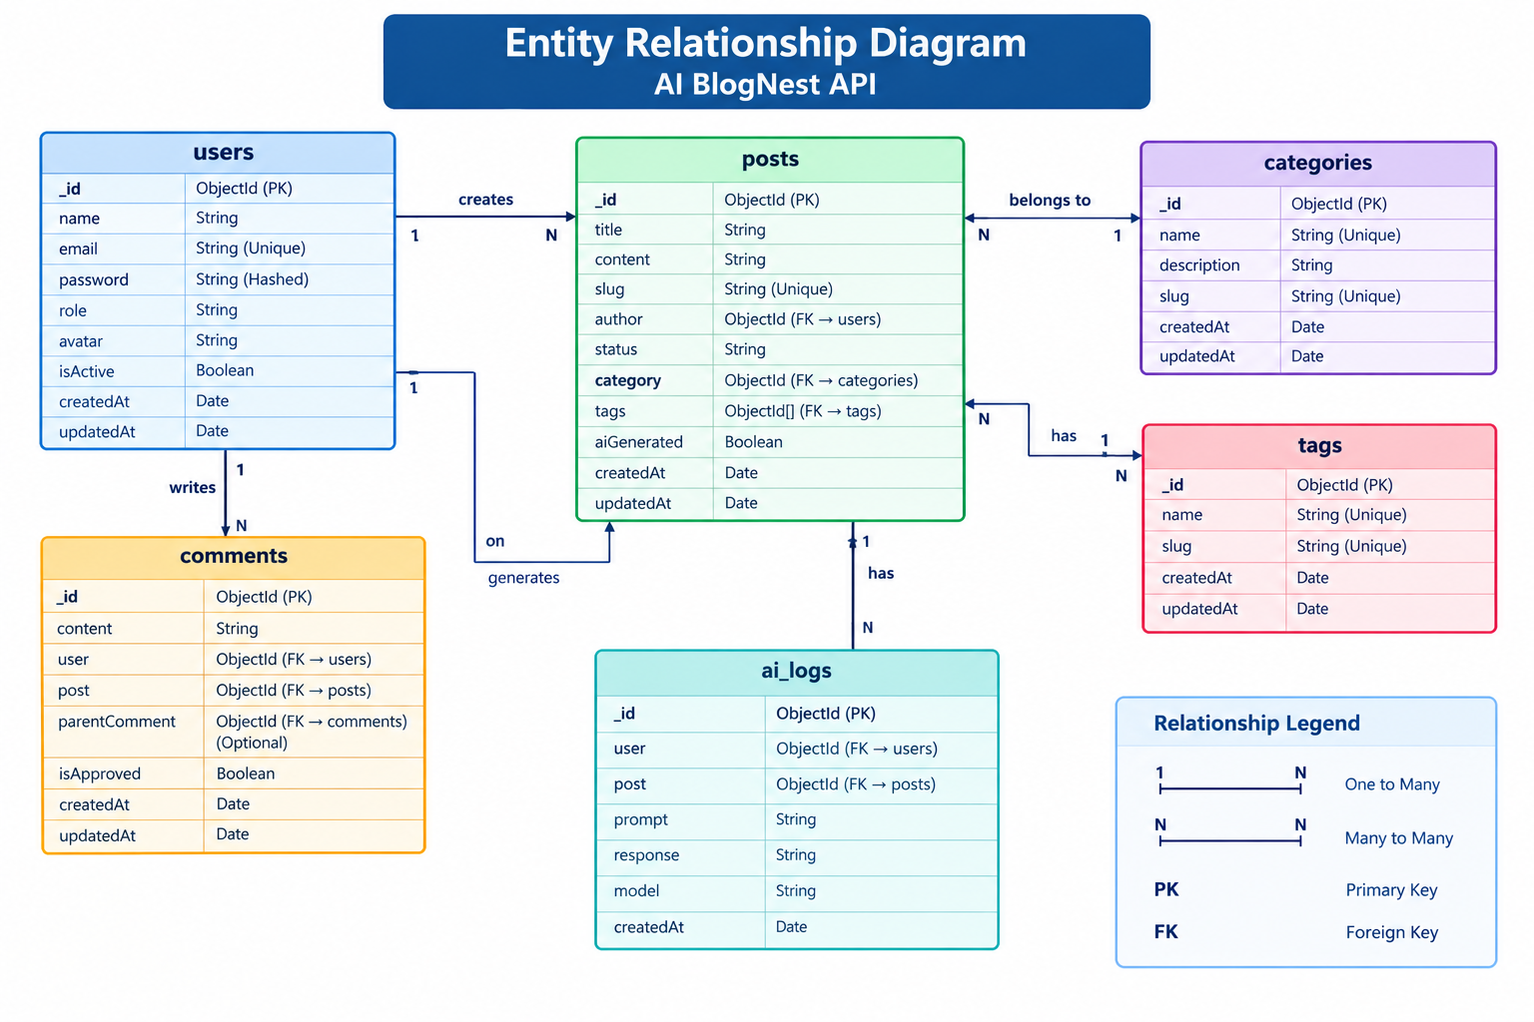

Relationship Explanation
- User → Blog: One user can create multiple blogs.
- Blog → Category: Each blog belongs to a category.
- Blog → Tag: A blog can have multiple tags.
- User → Comment: One user can write multiple comments.
- Blog → Comment: One blog can have multiple comments.
- User → AI Generation Log: One user can have multiple AI generation records.

20. USER ROLES AND RESPONSIBILITIES

AI BlogNest supports four user roles with different responsibilities:

Role | Responsibilities
Admin | Manages users, blogs, categories, comments, and overall system operations.
Editor | Reviews, manages, and publishes blog content.
Author | Creates and manages their own blog posts and content.
Reader | Views published blogs and participates through comments.
The role-based structure helps control access to different operations and provides appropriate permissions for each type of user.

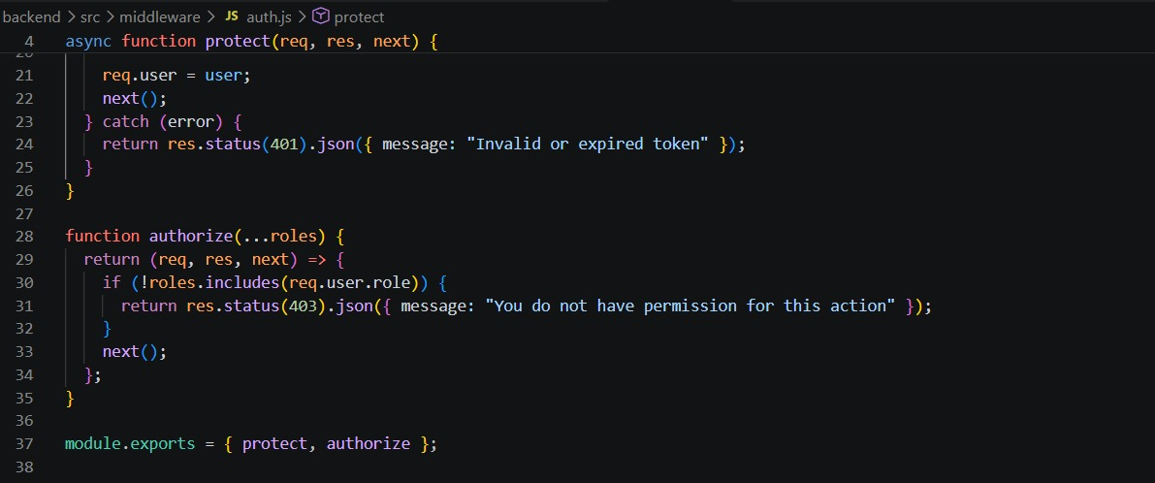
Role-based access control in AI BlogNest

21. AUTHENTICATION AND JWT

AI BlogNest uses JSON Web Token (JWT) authentication to secure protected API operations.

- Users authenticate using their registered credentials.
- Passwords are protected using bcryptjs hashing.
- After successful authentication, a JWT token is generated.
- The token is used to authenticate subsequent protected API requests.
- The JWT secret is stored securely in an environment variable rather than directly in the source code.
- The configured token expiration period is 7 days.
- JWT authentication helps prevent unauthorized access to protected resources.

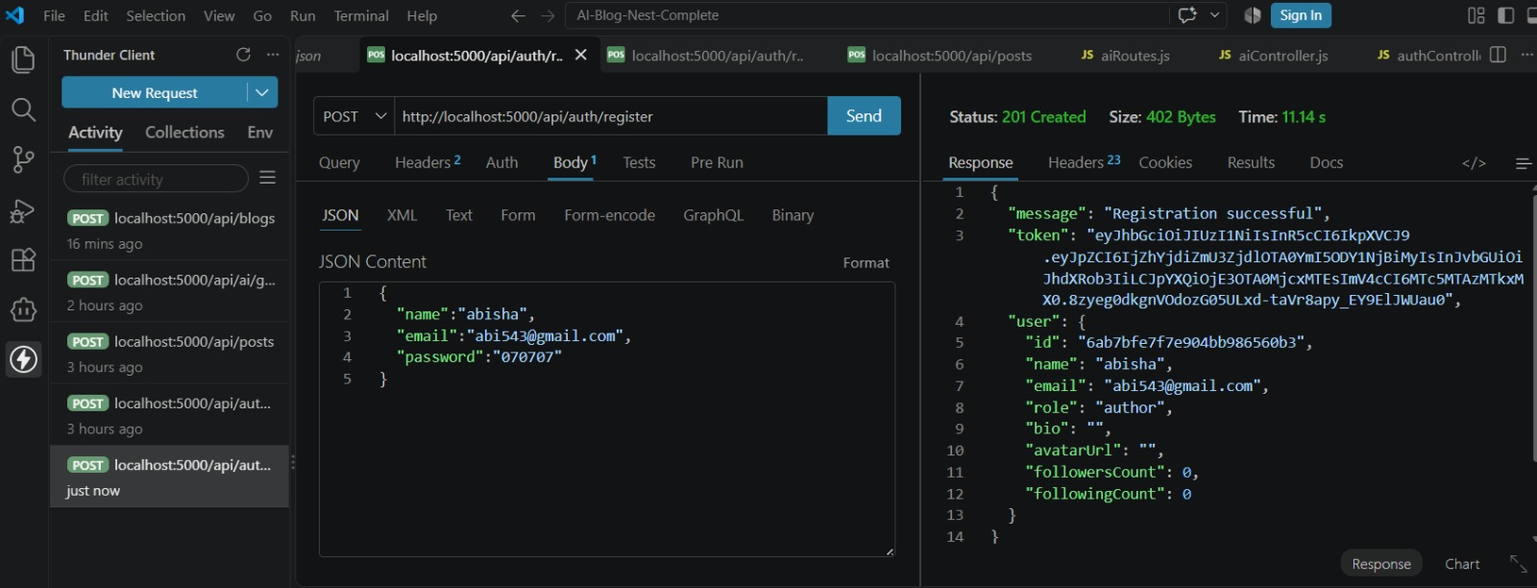
User registration
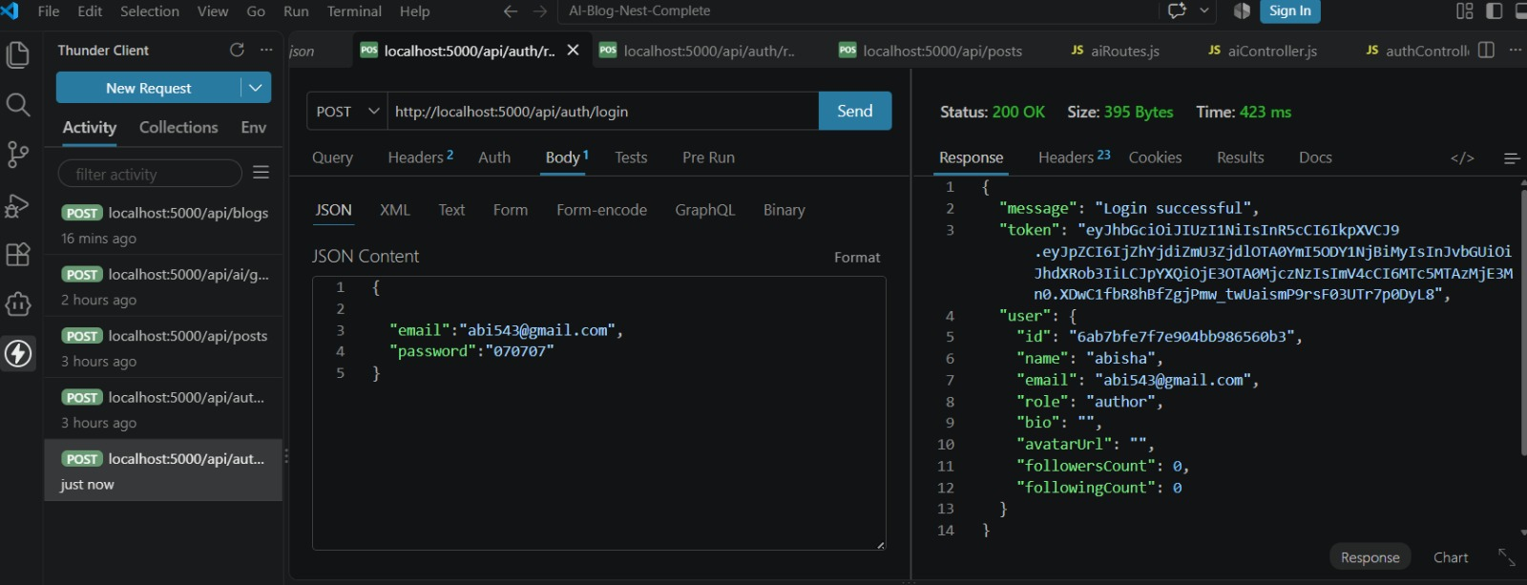
User login and JWT authentication

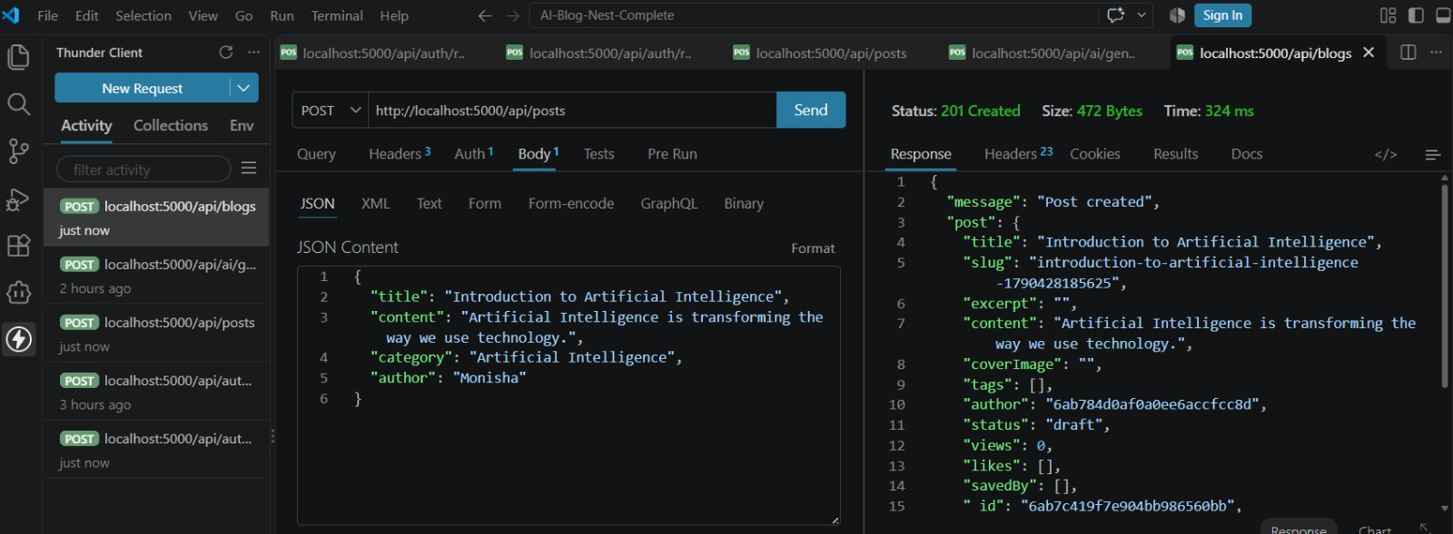

22. DATABASE CONFIGURATION

AI BlogNest API supports two database configurations.

Local Configuration

The local environment uses a MongoDB instance running on the local machine.
The database is configured as:
MongoDB: mongodb://127.0.0.1:27017/ai_blog_nest

Deployment Configuration
The deployment environment uses MongoDB Atlas.
The connection string is supplied through the MONGO_URI environment variable.
This approach allows the same application to operate in different environments without changing the source code.

23. ENVIRONMENT CONFIGURATION
Environment variables are used to configure the backend.
The main configuration parameters are:
Variable | Purpose
PORT | Backend server port
MONGO_URI | MongoDB connection
JWT_SECRET | JWT authentication secret
JWT_EXPIRES_IN | JWT token lifetime
GEMINI_API_KEY | Google Gemini API credential
GEMINI_MODEL | Gemini model selection
CORS_ORIGIN | Allowed frontend origins
The development configuration uses local MongoDB, while the deployment configuration can use MongoDB Atlas.
Sensitive values such as database credentials, JWT secrets, and Gemini API keys should remain private.

24. GOOGLE GEMINI AI INTEGRATION
AI BlogNest integrates Google Gemini AI to provide Generative AI capabilities for the blogging platform.
The project uses the @google/genai package to communicate with the Gemini service. The Gemini API key is stored in an environment variable to keep sensitive credentials separate from the application source code.
The AI configuration includes:
- Google Gemini: Generative AI service used by the backend.
- @google/genai: Node.js package used for Gemini API integration.
- GEMINI_API_KEY: Stores the Gemini API credential securely.
- GEMINI_MODEL: Specifies the Gemini model used by the application.
- Environment-based configuration: Allows the API key and model to be changed without modifying the application source code.
AI Integration Flow
User Request → Express.js Backend → Gemini API → AI-Generated Response → Backend → Client
The Gemini integration provides the foundation for AI-assisted content-related functionality in AI BlogNest. The exact AI operations and prompts depend on the implementation of the project's application and service modules.

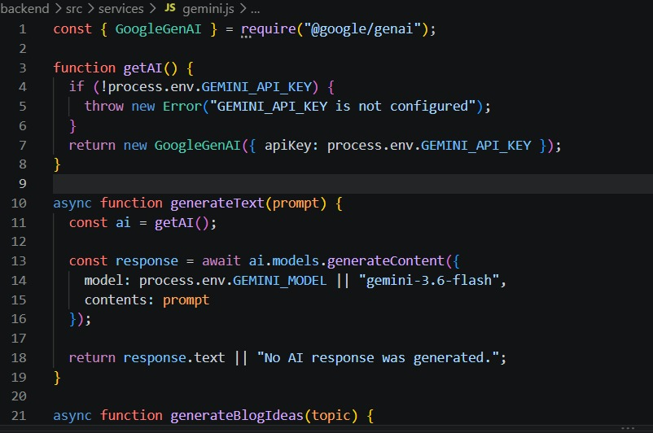

25. AI BLOG GENERATION
AI BlogNest uses Google Gemini AI to support automatic blog content generation. This feature helps reduce the manual effort required to create initial blog content.
The AI blog generation process follows these steps:
- The user provides a topic or relevant input for the blog.
- The request is sent to the AI BlogNest backend.
- The backend processes the request and communicates with the Google Gemini API.
- Gemini generates blog content based on the provided input.
- The generated content is returned to the backend.
- The backend sends the generated response to the client.
AI Blog Generation Flow
User Input → Express.js API → Gemini AI → Generated Blog Content → Backend Response → Client
The Gemini API key and model configuration are maintained through environment variables. The exact prompt structure and generation parameters depend on the implementation of the project's AI service.

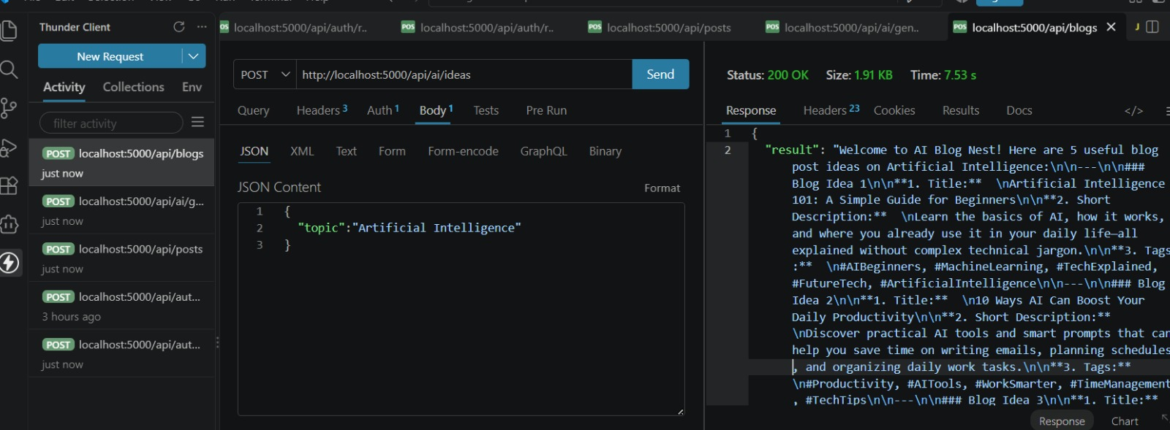

AI-powered blog generation using Google Gemini

26. PROMPT ENGINEERING

Prompt engineering involves designing clear and relevant instructions for Google Gemini to generate useful blog content. The prompt can include the blog topic, required content, and desired format to guide the AI response.

Flow:
User Topic → Structured Prompt → Gemini AI → Generated Blog Content

27. AI BLOG SUMMARIZATION

AI BlogNest uses Google Gemini AI to generate concise summaries from existing blog content. This helps users quickly understand the main points of longer articles.

Flow:
Blog Content → Backend API → Gemini AI → Generated Summary → Client

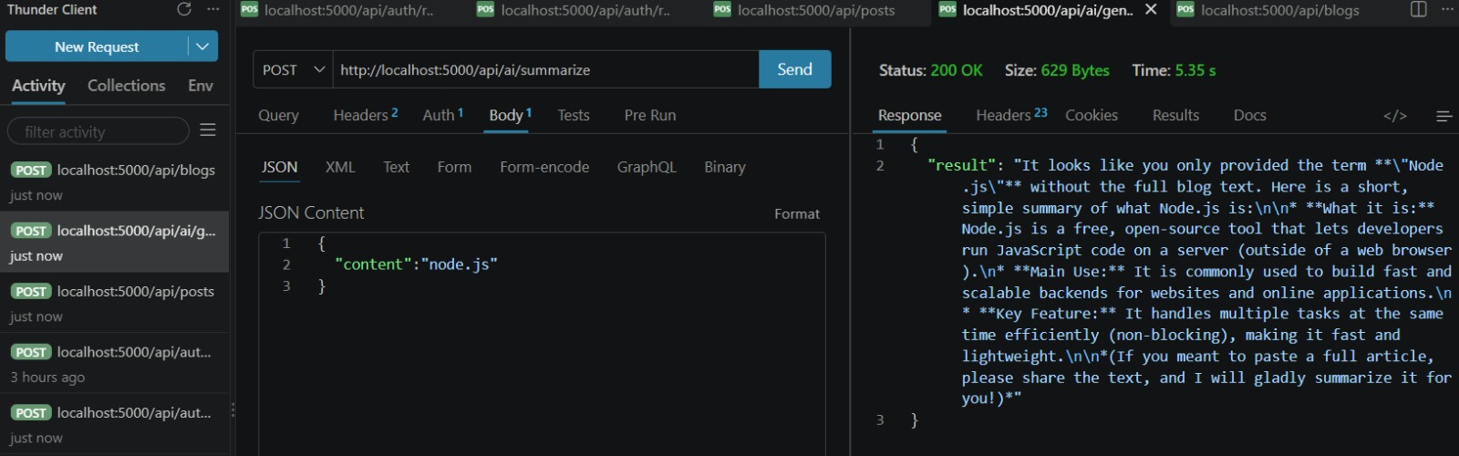
AI-powered blog summarization

28. MONGODB ATLAS SEARCH & VECTOR SEARCH INDEX

MONGODB ATLAS SEARCH & VECTOR SEARCH INDEX
MongoDB Atlas Search is used for keyword-based search, while MongoDB Atlas Vector Search is used for semantic search using vector embeddings.
- Atlas Search: Finds blog content based on keywords and text.
- Vector Search: Finds conceptually similar blog content using embeddings.
- Search Index: Defines how blog fields are indexed for searching.
- Vector Index: Stores configuration for vector-based similarity search.
- Purpose: Improves blog content discovery and allows users to find relevant content beyond exact keyword matches.

29. SEMANTIC SEARCH

SEMANTIC SEARCH
Semantic Search helps users find blog content based on meaning and context, rather than only matching exact keywords.
The search process is:
User Query → Generate Embedding → MongoDB Atlas Vector Search → Relevant Blog Results
It uses vector representations to identify content that is conceptually similar to the user's search query, even when different words are used.

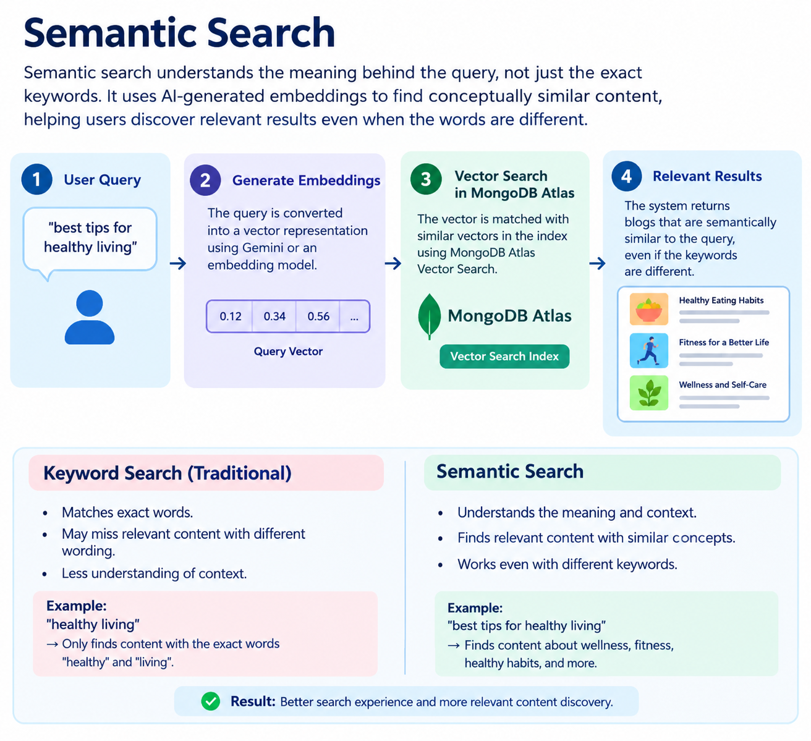.

30. API TESTING

API testing is performed to verify that the AI BlogNest REST API works correctly and returns the expected responses.
Postman can be used to test API requests, response data, status codes, authentication, validation, and error handling.
Testing Process
- Send API requests using Postman.
- Verify the HTTP status code.
- Check the response data and JSON structure.
- Test authentication and protected requests.
- Test invalid inputs and error responses.
- Verify database-related operations.
- Test AI-related API functionality.
Figure: API Testing using Postman

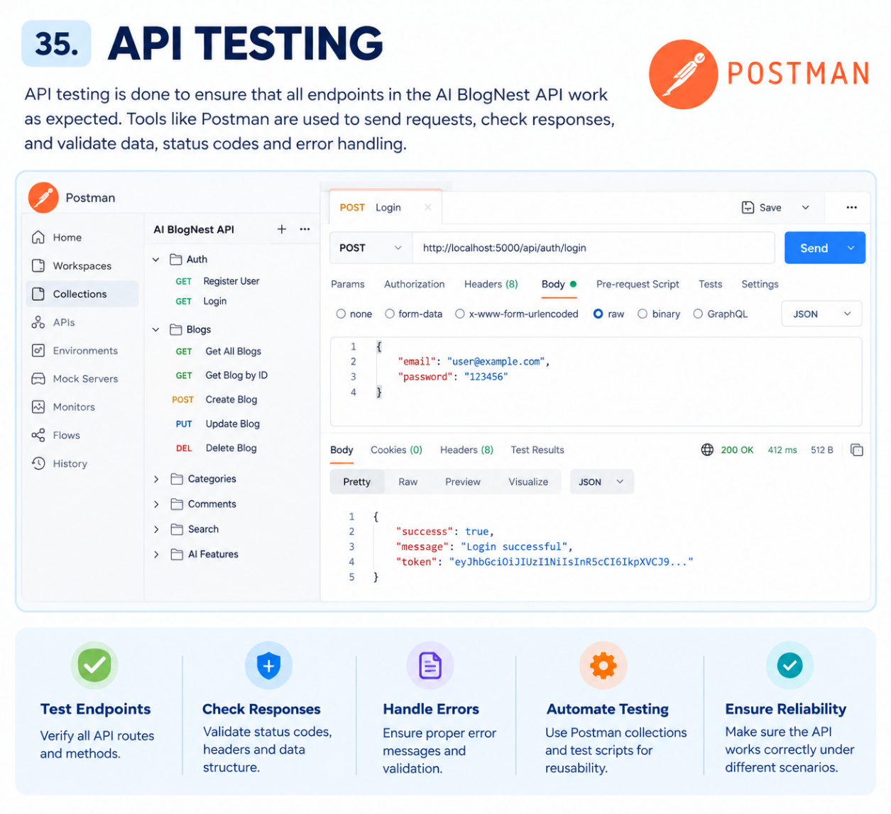

31. SYSTEM FUNCTIONALITY SUMMARY

Module | Main Functionality
Authentication | User registration, login and JWT authentication
Authorization | Admin, Editor, Author and Reader access
Blog Management | Create, view, update and delete blog content
Category | Manage blog categories
Comments | Add and manage comments
Gemini AI | AI blog generation and summarization
Search | Keyword-based and semantic search
Security | Password hashing, validation and rate limiting
Database | MongoDB and Mongoose-based data management
API | REST API communication through Express.js

32. ADVANTAGES

- AI-assisted blog generation.
- AI-powered blog summarization.
- Secure JWT authentication.
- Password protection using bcryptjs.
- Flexible MongoDB database support.
- Easy API development using Express.js.
- Request validation and security features.
- Environment-based configuration.
- Google Gemini AI integration.
- Easy to extend with future features.

33. LIMITATIONS

Backend Focus – The current project mainly focuses on backend REST API development and does not cover a complete frontend application.

Gemini Dependency – AI-based features depend on the availability and configuration of the Google Gemini API.

Database Dependency – The application requires MongoDB for storing and managing application data.

API Configuration – Proper configuration of environment variables such as database connection details, JWT settings, and Gemini API credentials is required.

AI Output Accuracy – AI-generated blog content and summaries may require user review and editing before use.

Scalability – Additional optimization and infrastructure may be required to support a large number of users and requests.

Testing Scope – Further automated and integration testing can be added to ensure reliability across different modules and deployment environments.

34. FUTURE ENHANCEMENTS
The AI BlogNest API can be further enhanced with additional features to improve functionality, usability, and scalability.
- Advanced AI Features – Add AI-powered content improvement, SEO suggestions, and personalized content assistance.
- Rich Blog Management – Support advanced editing, media management, categories, tags, and content workflows.
- Intelligent Search – Introduce improved keyword and semantic search capabilities for faster content discovery.
- User Management – Add detailed user profiles, preferences, and improved role-based management.
- Admin Dashboard – Provide a dashboard for monitoring users, blogs, comments, and system activities.
- Analytics – Add blog views, engagement statistics, and content performance reports.
- Automated Testing – Expand unit, integration, and API testing to improve system reliability.
- Scalability and Performance – Introduce caching, optimized database queries, and improved monitoring for larger workloads.
- Multilingual Support – Extend AI-assisted content generation and summarization to multiple languages.
- Deployment Improvements – Support automated CI/CD workflows and production monitoring.

35. CONCLUSION
AI BlogNest API provides a secure and intelligent backend solution for modern blog content management. The project combines Node.js, Express.js, MongoDB, Mongoose, JWT authentication, bcryptjs, and Google Gemini AI to support reliable backend operations and AI-assisted content creation.
The integration of Gemini AI enables features such as AI blog generation and blog summarization, helping reduce manual content creation effort. Security features including authentication, password hashing, request validation, rate limiting, CORS, and environment-based configuration provide a strong foundation for protecting the application.
Overall, AI BlogNest demonstrates how backend development and Generative AI can be combined to build a scalable blogging platform. The modular architecture also provides a foundation for future enhancements such as advanced content management, intelligent search, analytics, and additional AI-powered features.

